**ABOUT ORGANIZATION**



**TECHVULCAN**

Techvulcan is a technology based design services company work for IT services in collaboration with synapse design. The company provides system-on-chip design services from verification, physical design, and test vector development to testing and product commercialization. It was founded in 2011 by harper sir at Canada. Its first branch in India was opened in Bangalore in 2012. Its second branch in India was opened at Mumbai in 2015 and its thirdbranch as support branch in Kanpur in 2015.

**HQ LOCATION:-**San Diego, CA

|  |  |  |  |  |
| --- | --- | --- | --- | --- |
| Sector | Industry | sub-industry | Founded | No. of Employees |
| IT sector and Technology | Tech hardware | Semiconductor | 04/27/2010 | 100+ |

**INTRODUCTION**

# Tourism the act and process of spending time away from home in pursuit of recreation, relaxation, and pleasure, while making use of the commercial provision of services. Tourism is distinguished from exploration in that tourists follow a “beaten path,” benefit from established systems of provision, and, as befits pleasure-seekers, are generally insulated from difficulty, danger, and embarrassment. Tourism, however, overlaps with other activities, interests, and processes, including, for example, pilgrimage. This gives rise to shared categories, such as “business tourism,” “sports tourism,” and “medical tourism” (international travel undertaken for the purpose of receiving medical care). Here we provide for user and admin for easy traveling.

**PROJECT SCOPE**

**Tourism is considered to be an important aspect of economic growth and the development of a nation**. According to the United Nations World Tourism Organization (UNWTO), global tourism is expected to reach 1.6 billion (in terms of international arrivals) by the year 2020. Tourism **provides the opportunity for escapism**. Escapism can be good for the mind. It can help you to relax, which in turn often helps you to be more productive in the workplace and in every day life. This is another way that the importance of tourism is demonstrated.

**AIM AND OBJECTIVE**

* **To foster better knowledge of various cultures**. To improve the local population's quality of life. To provide both community and tourist-oriented facilities. To instill pride in one's traditional culture and identity. The most important economic feature of activities related to the tourism sector is that they contribute to three high-priority goals of developing countries: **the generation of income, employment, and foreign-exchange earnings**.
* STRATEGIC DEVELOPMENT AND SUSTAINABILITY OF AIRLINE INDUSTRY (CASE STUDY: AIR MALAWI)
* THE ROLE OF MARKETING IN HOTEL INDUSTRY (Case: Six successful hotel units in Abuja and Jakobstad)
* THE ROLE OF AVIS IN THE TOURISM DEVELOPMENT IN NIGERIA.

**METHODOLOGY**

**SYSTEM MODULE**

**PROJECT MODULE**

1.Admin module

a. Registration

b. Login

2. User module

a. Registration

b. Login

1. **Admin module**

Admin module allows system administrator to set up back end of the system and perform basic system configuration, mainly definition of predefined drop-down fields,

Definition of classes, time, schedule, etc.

Part of the admin set up is user management which allows users to be set up with definable access level/roles, access to a single or multiple branches. Admin can also set up overall system security settings such as required password strengths, inactive session time out, inactive accounts lock out, password reset period, etc.

Points in admin module is:-

a. Registration

b. Login

1. **User module**

The user module allows users to register, log in, and log out. Users benefit from being able to sign on because this associates content they create with their account and allows various permissions to be set for their roles.

The user module supports user roles, which can be set up with fine-grained permissions allowing each role to do only what the administrator permits. Each user is assigned one or more roles.

**SYSTEM RESOURCE REQUIREMENTS**

System requirements are the required specificationthe device must have in order to use certain hardware or software. For example, a computer may require a specific I/O port to work with a peripheral device. A Smartphone may need a specific operating system to run a particular app.

For “TEASON” to run on a specific computer system, some requirements are necessary for both hardware and software to be present in that particular computer system.

**HARDWARE RESOURCE REQUIREMENTS**

**Hard Disk :** 50 GB or above

**Processor** **:** Dual Coreor above

**Processor Speed:** 2.30GHz

**Ram**  **:** 2GB

**Monitor** **:** Display Panel (1024*76)

**SOFTWARE REQUIREMENTS**

**Operating system :** Windows, Linux, Mac etc.

**Database :** SQLite

**Frontend :** html, css, JS, ajax, bootstrap, mediaquerry

**Language :** Python

**Framework :** Django

**Frontend :-**

**SYSTEM DESIGN**

System design is the process of defining the components, modules, interfaces, and data for a system to satisfy specified requirements. System development is the process of creating or altering systems, along with the processes, practices, models, and methodologies used to develop them.

Core activities in system design and development include developing system-level technical requirements and top-level system design and assessing the design’s ability to meet the system requirements.

System-level technical requirements describe the user needs, and provide information for the finished system to meet legal restrictions, adhere to regulations, and interoperate or integrate effectively with other system.

Analysis can be defined as breaking up of any whole so as to find out their nature, function etc. It define design as to make preliminary sketches of to sketch a pattern or outline for plan .to plan and carry out especially by artistic arrangement or in a skillful wall. System analysis and design can be characterized as a set of techniques and processes, a community of interests, a culture and an intellectual orientation.

The various tasks in the system design include the following:-

* + Understanding application
  + Planning
  + Scheduling
  + Developing candidate solution
  + Performing trade studies
  + Performing cost benefit analysis
  + Supervising, installing and maintaining the system.

The main objective of this project is to help every person as soon as possible. If you have something extra food and unused items so donate these for others he needs it.

In others words, we can say that our project has the following objectives—

1. This application mainly consists of 2 persons – Doner and Receiver.
2. Doner and Receiver performs operations like Registration and login into the system.
3. Doner has no restriction, they donate anything to Receiver.
4. This project creates many benefits for the business and the community.
5. This project fully based on online, by taking it online it will help many people throughout the city/area/zip-area by donating food/items daily.

**Backend :-**

**Python** is great for machine learning

Because of its emphasis on code readability and its vast libraries and frameworks, **Python** is an ideal **backend language** when it comes to this area of technology. ... Moreover, **Python** has a vast set of libraries specific to machine learning, such as Keras, TensorFlow and Scikit-learn.

## “Python is the fastest-growing major backend language”

## Python has many web application frameworks

Python’s countless resources come in many forms, including a wide variety of web application frameworks. Here are just some you can choose from depending on the needs of your web app:

⦁ **Django**.  is a popular open-source Python web framework built by experienced developers. It aims at using automation wherever possible to speed up web development and let software developers focus on the important work. It is fast, secure and versatile.  
⦁ **Flask** is a Python web framework that provides various tools for developing web apps. Flask is considered a micro-framework, which means it pretty much has no dependencies to external libraries. This framework is light, flexible and easy to learn.  
⦁ **Bottle**. As another micro web framework,  is light, easy to integrate and customize, and depends solely on the Python Standard Library. Bottle is great for prototyping ideas and building simple web apps.  
⦁ **Tornado**.  is not only a web app framework but also an asynchronous library. It is ideal for developing long polling and WebSockets and has been dubbed a middle ground between Django and Flask.  
⦁ **CherryPy**.  is a minimalistic, object-oriented web framework that works wonders for web apps. It is fast, stable and versatile.  
⦁ **Hug**.  brands itself as a clean, obvious and simple framework for web development. It was built with performance in mind and includes built-in version management as well as automatic documentation.

## Python is easy to work with and easy to read

Python is known for its simple syntax and short code length. This, paired with the fact that there is also extensive documentation and tutorials available on its use, makes it fairly easy to learn. Moreover, Python is also extremely versatile and well-designed. If that wasn’t enough, Python is a platform-independent language, meaning that software created using Python can be used on a wide variety of operating systems with no need of an interpreter. All of this means that programmers can spend a lot of the time they usually devote to getting the code to run or figuring out how it works tackling the more meaningful challenges of their particular development project.

**SQLite :-** As a backend database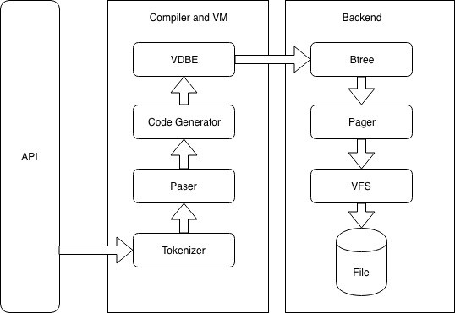

**SQLite** database architecture split into two different sections named as core and **backend**. Core section contains Interface, Tokenizer, Parser, Code generator, and the virtual machine, which create an execution order for database transactions. **Backend** contains B-tree, Pager and OS interface to access the file system.

**DFD :-**

The DFD represent a System requirement in a graphical form,this led to a modular design.A DFD is also known as bubble chart has the purpose of clarifying system requirements and identifying major transformations that will become programs in system design.so it is the starting point of the design phase that functionally decomposes the requirements specifications down to the lowest level of detail.A DFD consist of a series of bubbled joined by lines.The bubbles represent data transformations and the lines represent data flow in the system.

Context level DFD

*Name MobNo*

*Complaint*

*Document*

*OnLineComplaint*

*System*

*Complaint MobNo*

*Complaint*

*Document(Images)*

*User*

*Admin*

1-Level

User-id/pwd

*Log in*

*User/Admin*

Log in

*Login*

Notvalid Check(valid/not)

Admin Login

*Complaint List*

Gathering Data

Use rVisit Site

Visit

Complaint Box

Submit complaint

Mobno Complain Images

E-R Diagram :

In this model objects of similar structures are collected into an entity set.The relationship between entity sets is represented by a named E-R relationship and is 1:1(one to one),1:N(one to many) or M:N(many to many) mapping from one entity set to another.The database structures,employing the E-R model is usually shown pictorially using entity relationship(E-R)diagrams.The E-R diagram are useful in representing the relationship among entitites.The following terms used in E-R Diagram :-

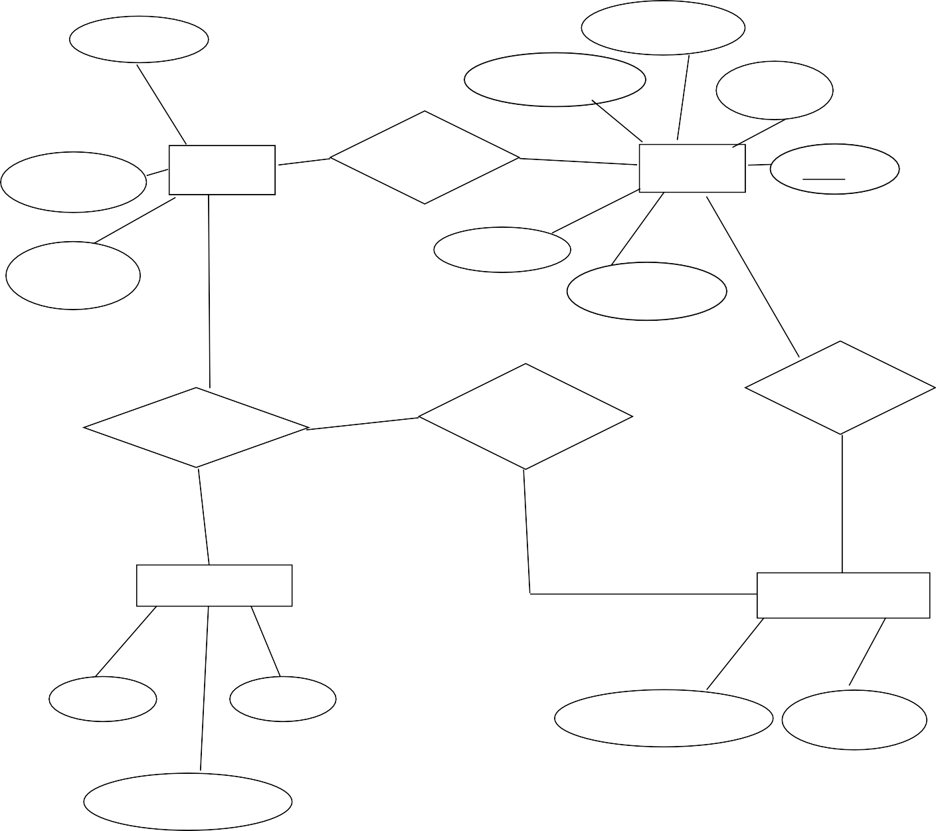

*Serial-no*

*Last*

*Contact_no*

*name*

*Passwords*

*Admin*

*Manage*

*User*

*serial*

*Name*

*e-mailid*

*password*

*issues*

*Generate*

*Manages*

*Report*

*Complain*

*I*

*Name*

*ComplaintText*

*Image*

*Complain*

**Entity**:-An entity is a person,place ,thing,event or concept about which information is recorded.

**Attribute**:-Attribute gives the characterstic of the entity.In other words,every entity has some basic attribute that characterize it.

**Entity Type**:-An entity type is defined as a collection of entities that have the **same** attributes.

**EXPECTED TIME SCHEDULE**

**(Gantt Chart)**

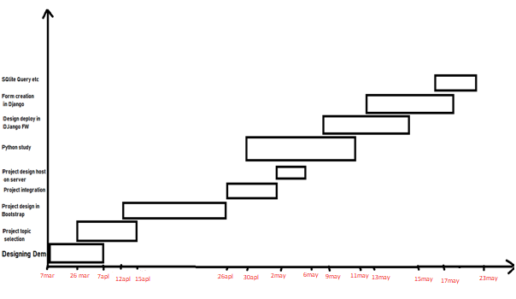

**IMPECT OF PROPOSED SYSTEM IN ACADEMICS AND INDUSTRY**

**TECHNOLOGY**

Frontend:-

1. HTML(Hypertext Markup Language):-

2. CSS(Cascading Style Sheet)

3. BOOTSTRAP ( web framework)

4. JAVASCRIPT (**JavaScript** allows users to interact with web pages.)

5. Ajax

Backend:-

Python (programming language)

Database:-

SQLite

Framework:-

DJango

FRONTEND:--

1. HTML(Hypertext Markup Language):-

It provide to create structured documents including images, lists and other items. It is the language understanding by browser. HTML is the standard markup language for documents designed to be displayed in a web browser. It can be assisted by technologies such as Cascading Style Sheets (CSS).

Web browsers receive HTML documents from a web server or from local storage and render the documents into multimedia wed pages. HTML describes the structure of a web page semantically and originally included cues for the appearance of the document.

1. CSS(Cascading Style Sheet) :-

It can be applied to bring the style in the web documents. CSS is a style sheet language used for describing the presentation of a document written in a markup language like HTML. CSS is a cornerstone technology of the world wide web, alongside HTML and java Script.

CSS is designed to enable the separation of presentation and content, including layout, colors and fonts. This separation can improve content accessibility, provide more flexibility and control in the specification of presentation characteristics, enable multiple web pages share formatting by specifying the relevant CSS in a separate.

The name *cascading* comes from the specified priority scheme to determine which style rule applies if more than one rule matches a particular element. This cascading priority scheme is predictable.

1. BOOTSTRAP:-

Bootstrap is a web framework that focuses on simplifying the development of informative web pages . The primary purpose of adding it to a web project is to apply Bootstrap's choices of color, size, font and layout to that project. As such, the primary factor is whether the developers in charge find those choices to their liking. Once added to a project, Bootstrap provides basic style definitions for all HTML elements. In addition, developers can take advantage of CSS classes defined in Bootstrap to further customize the appearance of their contents. For example, Bootstrap has provisioned for light- and dark-colored tables, page headings, more prominent pull quotes, and text with a highlight.Bootstrap is a free and open source CSS framework directed at responsive, mobile first front end web development. It contains CSS and (optional) Java Script based design templates for forms, buttons, navigation and other interface components.

BACKEND:

PYTHON

Python is a popular programming language. It was created by Guido van Rossum, and released in 1991.

It is used for:

* web development (server-side),
* software development,
* mathematics,
* system scripting.

What can Python do?

* Python can be used on a server to create web applications.
* Python can be used alongside software to create workflows.
* Python can connect to database systems. It can also read and modify files.
* Python can be used to handle big data and perform complex mathematics.
* Python can be used for rapid prototyping, or for production-ready software development.

Why Python?

* Python works on different platforms (Windows, Mac, Linux, Raspberry Pi, etc).
* Python has a simple syntax similar to the English language.
* Python has syntax that allows developers to write programs with fewer lines than some other programming languages.
* Python runs on an interpreter system, meaning that code can be executed as soon as it is written. This means that prototyping can be very quick.
* Python can be treated in a procedural way, an object-orientated way or a functional way.

SQLITE

* **SQLITE DATABASE :--**

It is used to create a database. Python provide a server for the database is called Sqlite , software that allows you to insert ,retrieve ,modify or delete the records.

SQLite is a software library that provides a relational database management system. The lite in SQLite means lightweight in terms of setup, database administration, and required resources.

SQLite has the following noticeable features: self-contained, serverless, zero-configuration, transactional.

### Server less

Normally, an RDBMS such as MySQL, PostgreSQL, etc., requires a separate server process to operate. The applications that want to access the database server use TCP/IP protocol to send and receive requests. This is called client/server architecture.

* The following diagram illustrates the RDBMS client/server architecture:

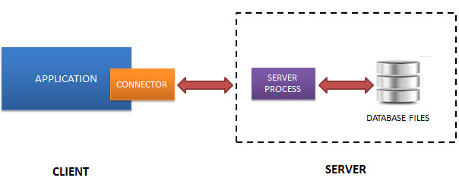

* SQLite does NOT work this way.
* SQLite does NOT require a server to run.
* SQLite database is integrated with the application that accesses the database. The applications interact with the SQLite database read and write directly from the database files stored on disk.
* The following diagram illustrates the SQLite server-less architecture:

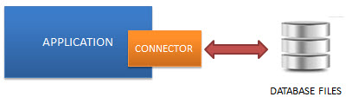

### Self-Contained

SQLite is self-contained means it requires minimal support from the operating system or external library. This makes SQLite usable in any environment especially in embedded devices like iPhones, Android phones, game consoles, handheld media players, etc.

SQLite is developed using ANSI-C. The source code is available as a big sqlite3.c and its header file sqlite3.h. If you want to develop an application that uses SQLite, you just need to drop these files into your project and compile it with your code.

### Zero-configuration

Because of the serverless architecture, you don’t need to “install” SQLite before using it. There is no server process that needs to be configured, started, and stopped.

In addition, SQLite does not use any configuration files.

### Transactional

All transactions in SQLite are fully ACID-compliant. It means all queries and changes are Atomic, Consistent, Isolated, and Durable.

In other words, all changes within a transaction take place completely or not at all even when an unexpected situation like application crash, power failure, or operating system crash occurs.

## SQLite distinctive features

SQLite uses dynamic types for tables. It means you can store any value in any column, regardless of the data type.

SQLite allows a single database connection to access multiple database files simultaneously. This brings many nice features like joining tables in different databases or copying data between databases in a single command.

* SQLite is capable of creating in-memory databases that are very fast to work with.

DJANGO

* Django(Framework):-- Django is a free, open-source Python based high level web framework. It follows the model view templates(MVT) Architectural pattern. Django provide SQLite database by default.

Django is a web development framework that assists in building and maintaining quality web applications. Django helps eliminate repetitive tasks making the development process an easy and time saving experience. This tutorial gives a complete understanding of Django.

Django is a high-level Python web framework that encourages rapid development and clean, pragmatic design. Django makes it easier to build better web apps quickly and with less code.

**Note** − Django is a registered trademark of the Django Software Foundation, and is licensed under BSD License.

## History of Django

* **2003** − Started by Adrian Holovaty and Simon Willison as an internal project at the Lawrence Journal-World newspaper.
* **2005** − Released July 2005 and named it Django, after the jazz guitarist Django Reinhardt.
* **2005** − Mature enough to handle several high-traffic sites.
* **Current** − Django is now an open source project with contributors across the world.

## Django – Design Philosophies

Django comes with the following design philosophies −

* **Loosely Coupled** − Django aims to make each element of its stack independent of the others.
* **Less Coding** − Less code so in turn a quick development.
* **Don't Repeat Yourself (DRY)** − Everything should be developed only in exactly one place instead of repeating it again and again.
* **Fast Development** − Django's philosophy is to do all it can to facilitate hyper-fast development.
* **Clean Design** − Django strictly maintains a clean design throughout its own code and makes it easy to follow best web-development practices.

## Advantages of Django

Here are few advantages of using Django which can be listed out here −

* **Object-Relational Mapping (ORM) Support** − Django provides a bridge between the data model and the database engine, and supports a large set of database systems including MySQL, Oracle, Postgres, etc. Django also supports NoSQL database through Django-nonrel fork. For now, the only NoSQL databases supported are MongoDB and google app engine.
* **Multilingual Support** − Django supports multilingual websites through its built-in internationalization system. So you can develop your website, which would support multiple languages.
* **Framework Support** − Django has built-in support for Ajax, RSS, Caching and various other frameworks.
* **Administration GUI** − Django provides a nice ready-to-use user interface for administrative activities.
* **Development Environment** − Django comes with a lightweight web server to facilitate end-to-end application development and testing.

**ROLES AND RESPONSBILITY**

Entire project itself

**PROS AND CONS**

Tourism is a massive industry everywhere in the world, and there are some remarkable advantages to this in each country.  Sometimes tourism is the main source of foreign income, boosting the economy for the beautiful countries around the world. For tourists themselves, the benefits to happiness and wellbeing are immense!

However, even with these benefits, there are some downsides that may balance the scale when it comes to tourism. The negatives involved can have lasting effects as well – we will have a look at some of these in this article.

It can be very easy to overlook these darker aspects of tourism. Why would you want to look at the negative aspects, when you look at the way tourism has brought vast wealth to many countries that needed it and thrive from it. The thing is though, we need to see the big picture, and in order to do so – we indeed need to consider all angles.

If we ignore the negative effects of tourism and do not deal with them appropriately we will be responsible for them spiraling out towards chaos.

**REFERENCES**

* https://www.javatpoint.com/php-tutorial
* https://www.quora.com
* https://www.tutorialspoint.com/php/index.htm
* https://www.stackoverflow.com/
* https://www.w3schools.com/css

**CONCLUSION**

Easy and use full platform for user and admin .

## **FUTURE SCOPE OF THE PROJECT**

Tourism is considered to be an important aspect of economic growth and the development of a nation. According to the United Nations World Tourism Organization (UNWTO), **global tourism is expected to reach 1.6 billion (in terms of international arrivals) by the year 2020**.